
AMERICAN INTERNATIONAL UNIVERSITY-BANGLADESH (AIUB)
Department of CSE
Computer-Aided Design and Drafting

Section: L
Experiment No: # 03
Name: Khan, Md. Sazzad
Id: 22–49172-3
Supervised by: MD. RAKIBUL ISLAM CHOWDHURY

Name of Experiment: Familiarization with different orthographic projections and drawing using AutoCAD software

AutoCAD Comments:

- How To Input Dotted Line In AutoCAD :

Type linetype >> Enter >> Click Load >> Select Desired Line >> ok
>> ok
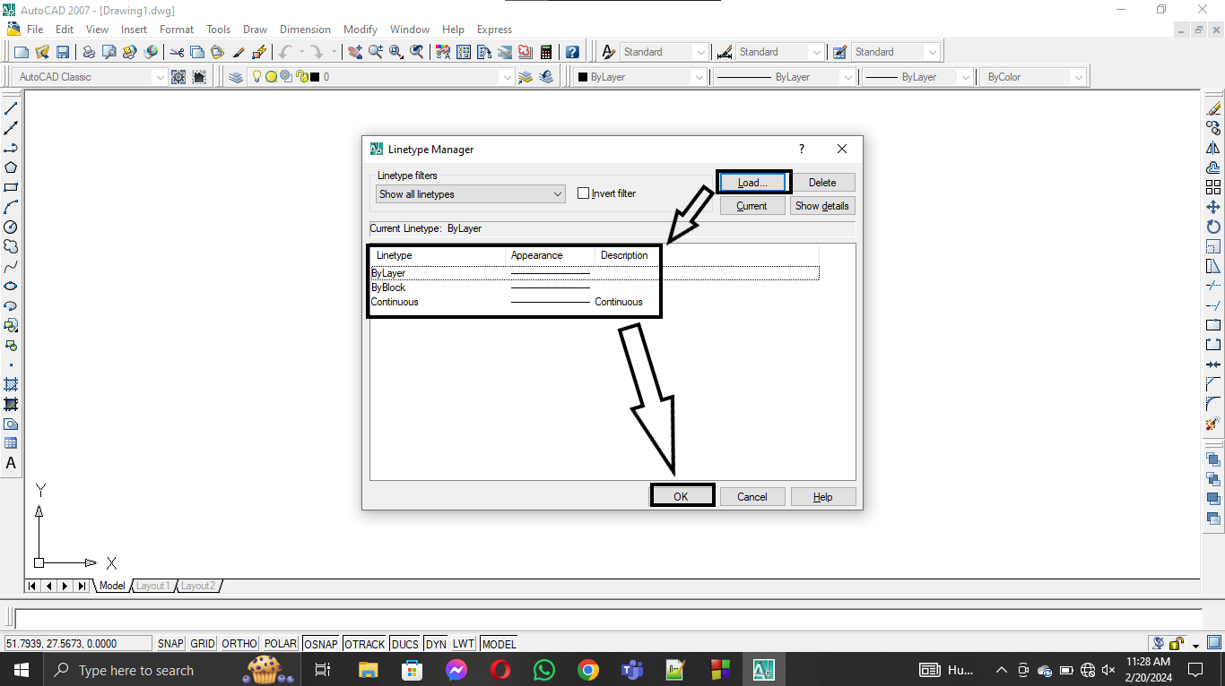

- How To Plot A Drawing In AutoCAD :

Select File >> Plot >> Name : Select One >> Page size : A4 >>
What to plot: Window >> Click Center The Plot >> ok

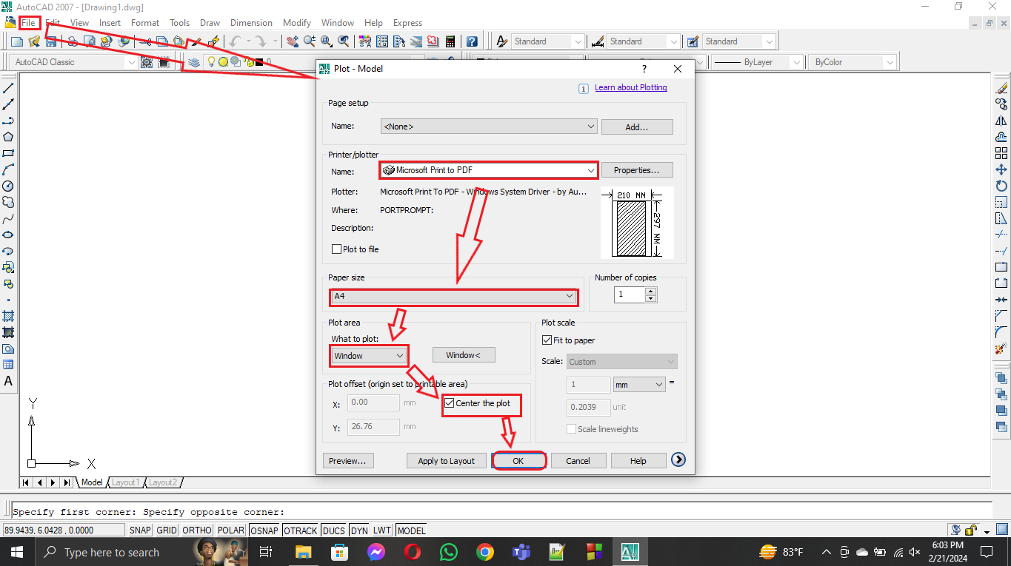

- How To Write Text In AutoCAD :

Type mtext >> Enter >> Click on Starting point >> Click another
Point >> Write >> ok

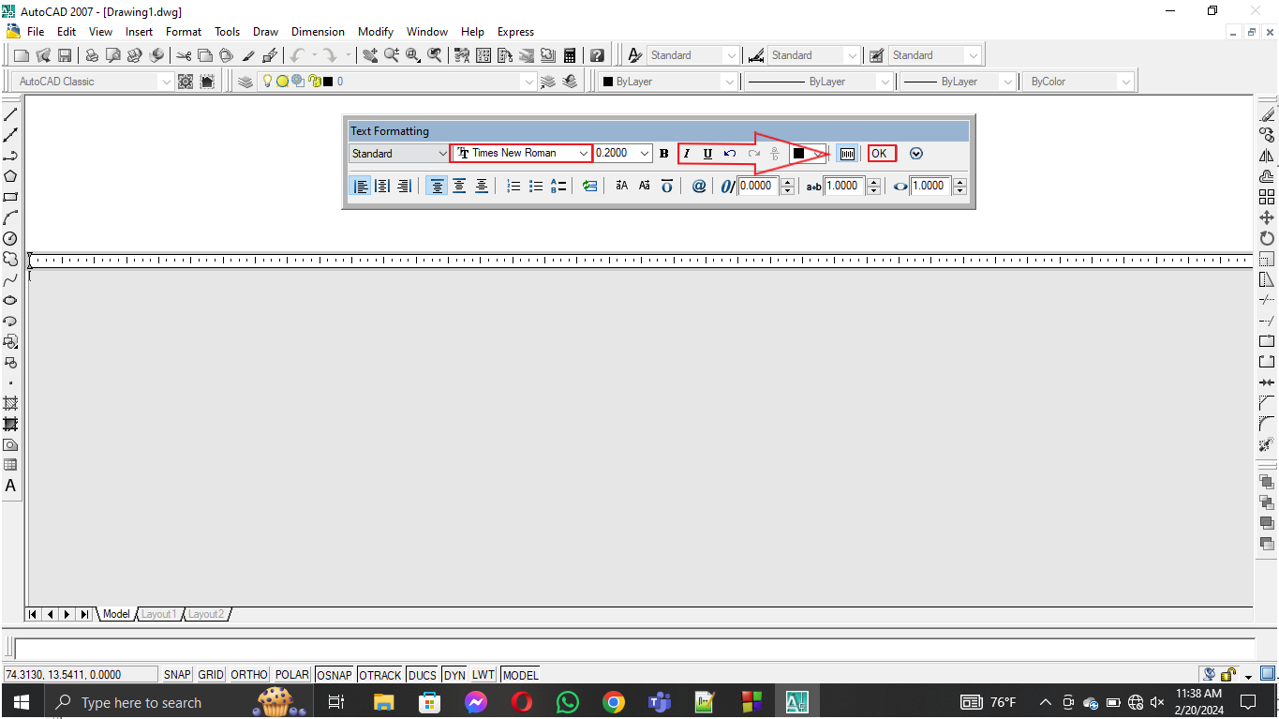

- How To Move In AutoCAD :

Type Co >> Enter >> Select Objects >> Enter >> Click on base point >> put the crosshair in the side which you want to move >> input move distance or Click at a random point >> Enter

- How To Copy In AutoCAD :

Type Co >> Enter >> Select Objects >> Enter >> Click on base point >> put the crosshair in the side which you want to copy >> input copy distance >> Enter

